?????? Base

My name is ?????? and
I will be joining ????? Base in September

This is my new classroom. It is called ????? Base and is in the ??????????? building.

My new teacher is ????????

The class teaching assistant is ????????

??????????
???????????

My LSA’s are ??????? (in the morning) &
?????????? (in the afternoon)

My new class is in the ???????? building and I will use this door to get to my classroom.

I hang my coat, bag and PE kit on the pegs outside my classroom.

I will play in the ??????? playground or the field.

The nearest toilets are at the end of the corridor. This is what the door looks like.

The nearest water fountain is ?????????

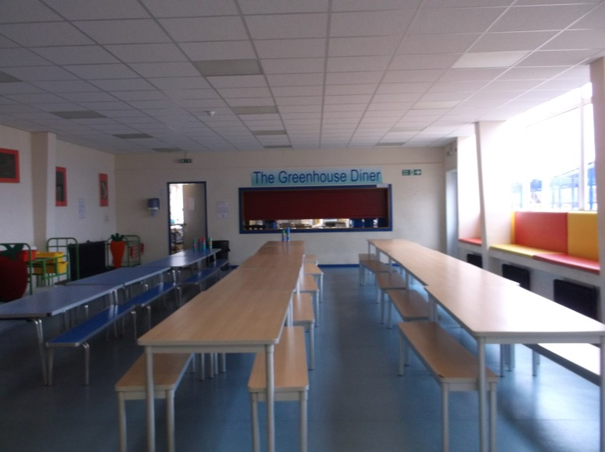

Dinner Hall Forest Room

I will be eating my hot dinner or sandwiches’ in the
dinner hall.

If I need to go to the medical room, I will go to the medical room in the ???????? building

When I leave school in the afternoon, I will use this door.

